Lesson 4 Demo 9: Enabling Security

This section will guide you to:

* Enable security in jenkins

This lab has three sub-sections, namely:

1. Enabling security Jenkins

2. Setting up an account

**Step 1:** Enabling security Jenkins

* Go to Jenkins **dashboard**.
* Click on ***Manage Jenkins*** and select ***Configure Global Security***.

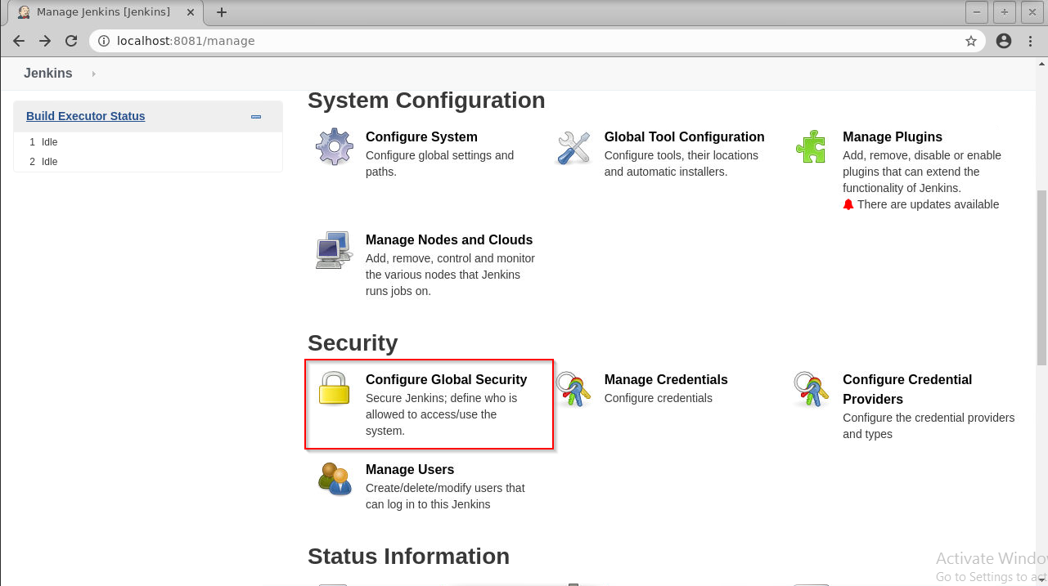

* Under *Security Realm*, choose ***Jenkins’ own user database*** and check the box that says ***Allow users to sign up***.

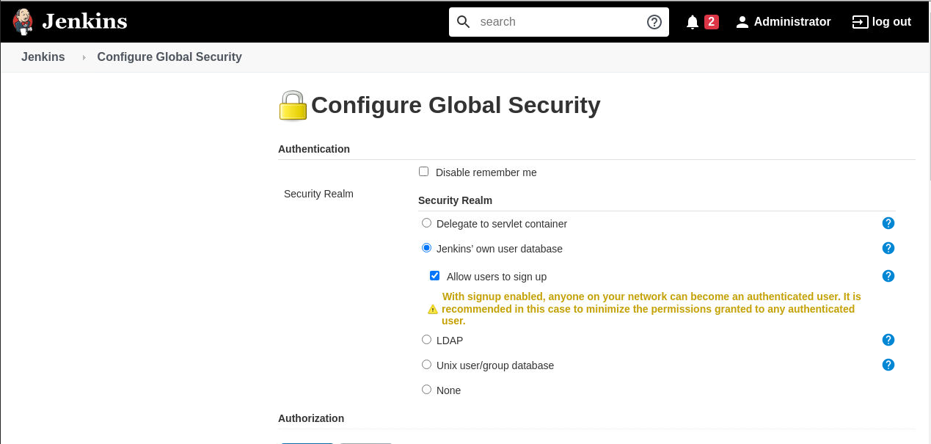

* Under *Authorization*, select ***Logged-in users can do anything***.

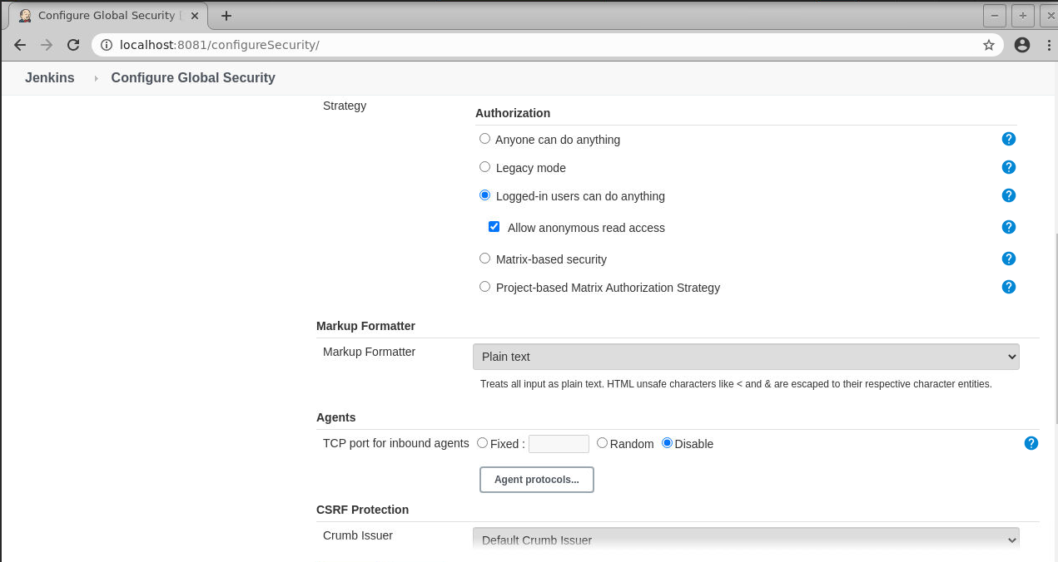

* Click **Save**.

**Step 2:** Setting up an account

* Navigate to the Jenkins Dashboard.
* Click on Sign up at the top right corner.

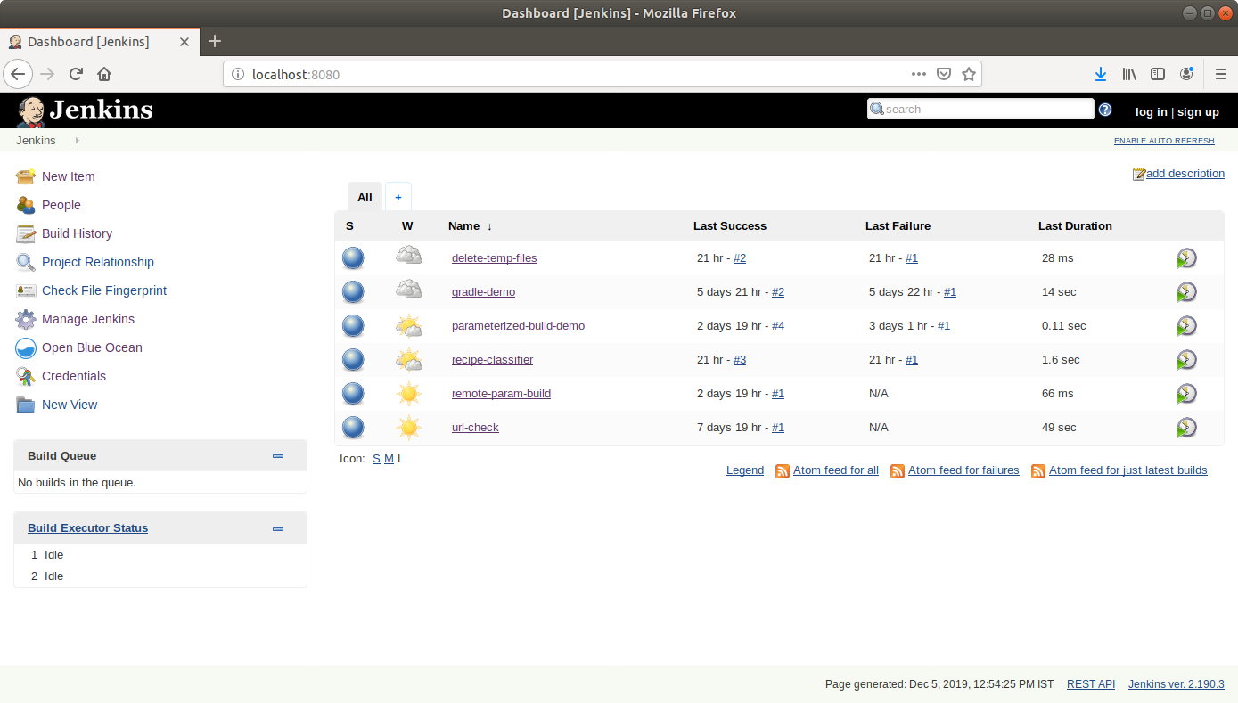

* Fill the required fields in the sign up form.

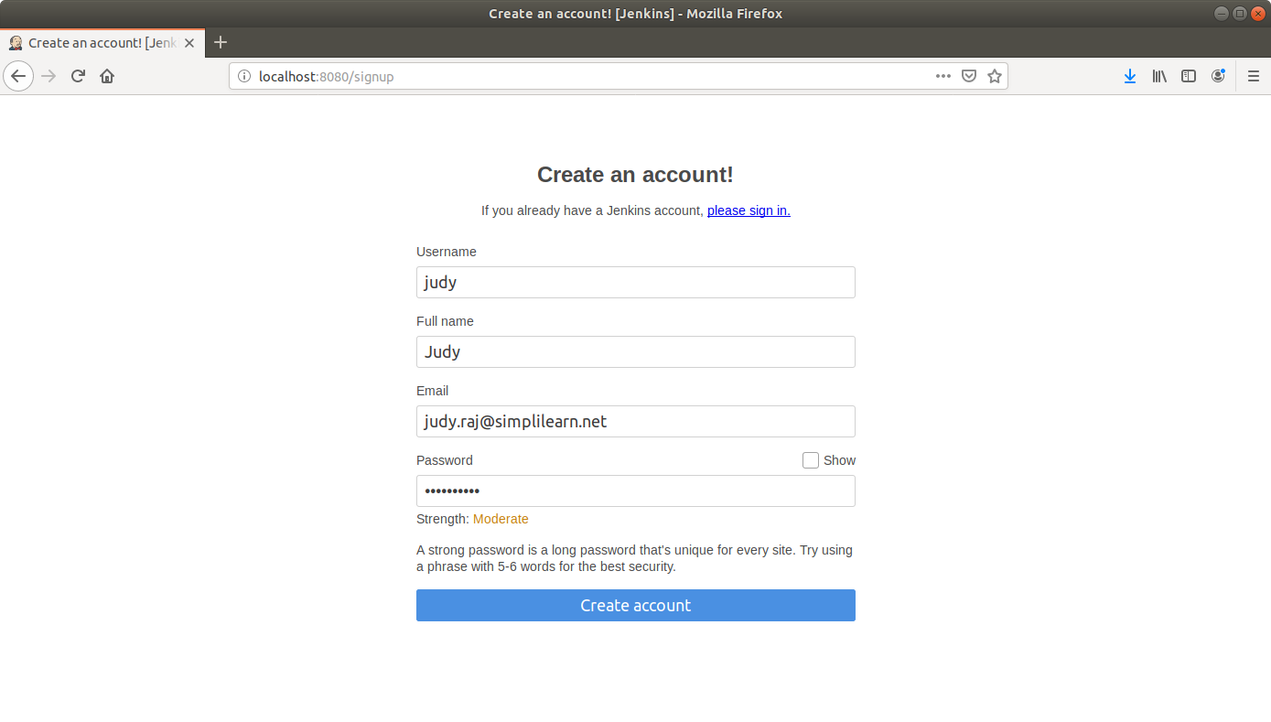

* Click ***Create account***.
* You can now log in with your credentials.